Odd Semester (2022)



**BINUS UNIVERSITY**

**BINUS INTERNATIONAL**

**Assignment Cover Letter**

**(Individual Work****)**

|  |  |  |  |  |  |  |  |  |
| --- | --- | --- | --- | --- | --- | --- | --- | --- |
|  | | | | |  | |  | |
| **Student Information**: **Surname** | | | | | **Given Names**  **Kennyvito Salim** | | **Student ID Number**  **2201811391** | |
| 1. | | **Klementinus** |  | |
|  |  |
| **Course Code** | **: COMP6056** |  |  | | **Course Name** | | **Program Design Methods** | |
| **Class** | **: L1AC** |  |  | | **Name of Lecturer(s)** | | **:** 1. Minaldi Loeis | |
|  |  |  |  | |  | |  | |
| **Major** | **: CS** |  |  | |  | |  | |
| **Title of Assignment**  (if any) | : Food for Folks | |  |  | |  | |  | |
| **Type of Assignment**    **Submission Pattern** | **: Final Project** |  |  | |  | |  | |
| **Due Date** | **: 20-11-2018** |  |  | | **Submission Date** | | **: 20-11-2018** | |

The assignment should meet the below requirements.

1. Assignment (hard copy) is required to be submitted on clean paper, and (soft copy) as per lecturer’s instructions.
2. Soft copy assignment also requires the signed (hardcopy) submission of this form, which automatically validates the softcopy submission.
3. The above information is complete and legible.
4. Compiled pages are firmly stapled.
5. Assignment has been copied (soft copy and hard copy) for each student ahead of the submission.

# Plagiarism/Cheating

BiNus International seriously regards all forms of plagiarism, cheating and collusion as academic offenses which may result in severe penalties, including loss/drop of marks, course/class discontinuity and other possible penalties executed by the university. Please refer to the related course syllabus for further information.

# Declaration of Originality

By signing this assignment, I understand, accept and consent to BiNus International terms and policy on plagiarism. Herewith I declare that the work contained in this assignment is my own work and has not been submitted for the use of assessment in another course or class, except where this has been notified and accepted in advance.

Signature of Student: (Name of Student)

1.Klementinus Kennyvito Salim

“Food for Folks”

Name: Klementinus Kennyvito Salim

NIM: 2201811391

**Explore the Cooking World**

“An application designed to anyone who cooks out there”  
**Problem and Introduction:**

In our world, there is no such thing as ‘instant’. Everything needs process, whether it is wanted or unwanted. Even while you fill your stomach, it’s either you wait someone to cook for you or you cook by yourself, then you eat. Everything needs process. In here, you can explore the cooking world by doing a very simple thing: input your ingredients that you have readily and that it will show you all the food that you can make with those ingredients. Thus, we name it “Food for Folks”

For example, you only had carrots, peas, ham, rice, and cheese. You input these ingredients to the machine, and it will tell you what can you cook with them, with the exception of little ingredients that you normally have (salt, pepper, oil, etc.). For instance, you can either make fried rice with those ingredients, or another option of cooking the ham, cheese, carrots, peas together and rice as the main energy source.

With that in mind, you can easily put ingredients into the program’s deliberative and simple interface and it will deliver you recipes that you can follow to cook. Everyone can use this program, even those who had no idea what to cook and just needed to finish off their ingredients since they will be away for days, for example.

**What APIs were used?**

This project will use Python as the programming language. It will use tkinter as its base to create the interface , together with webbrowser and PIL for the images.

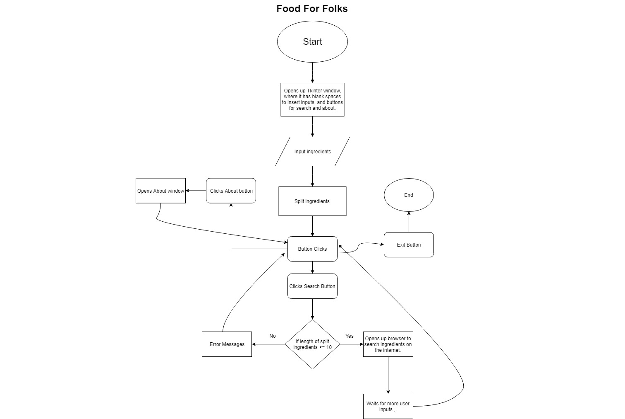**Design :**

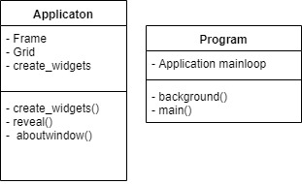

**Discussion :**

This program is made using the tkinter package, together with webbrowser and PIL. Tkinter package is used to create and make the interface, where it will open a new window in your screen to input the ingredients that you would like to cook with. Webbrowser package will open a new tab at your default browser to search for the recipes. PIL is used to set background images of the interface.

All in all, how the program works is that when you run the program, it will open a new window and shows a blank space to enter your ingredients, and you can add more ingredients using a single space. This program only works for up to ten ingredients total, or else it will show an error message. When you finish typing in your ingredients, click on the search button and it will open your browser and recipes will be showed on a new tab. However, there is another “About us” button, and if you click it , a new window will open up and it writes the description of the program.

Two classes were used : Application class and Program class. The Application class contains mostly the “core” of the program where widgets such as the search bar and buttons were made, and also commands for the secondary “About us” window. The program class is rather the main commands to run the Application class.

**Evidence:**

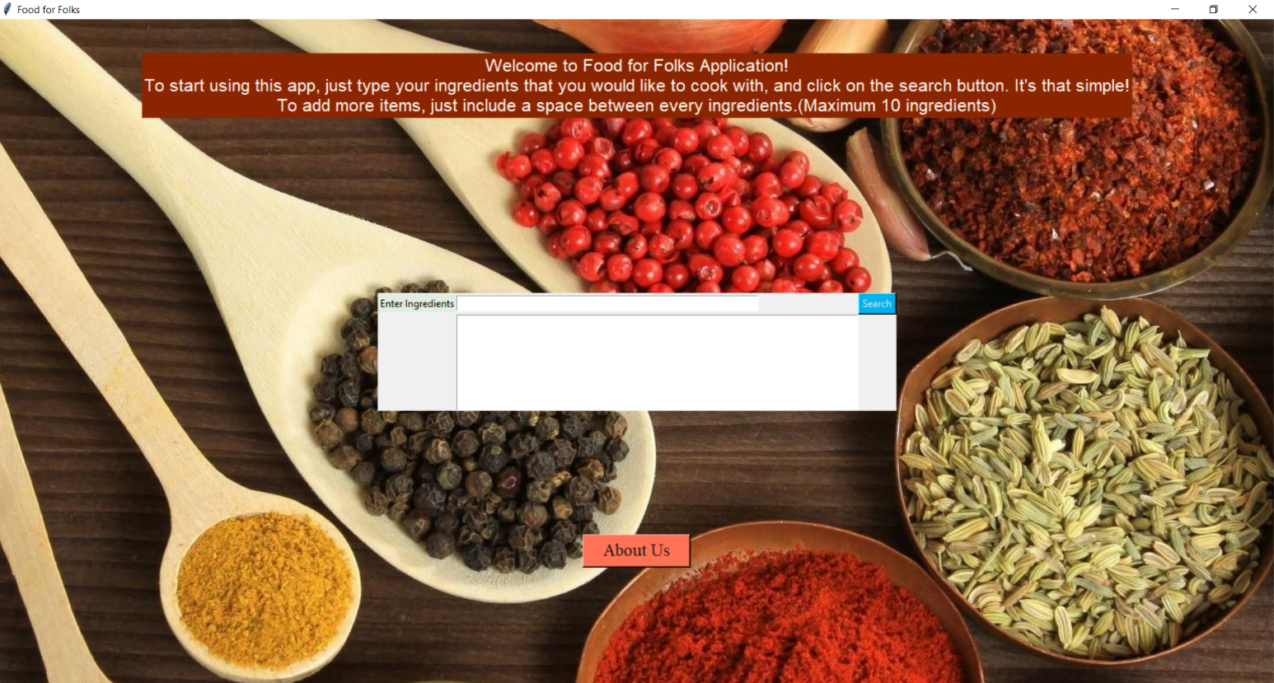

The Food for Folks window

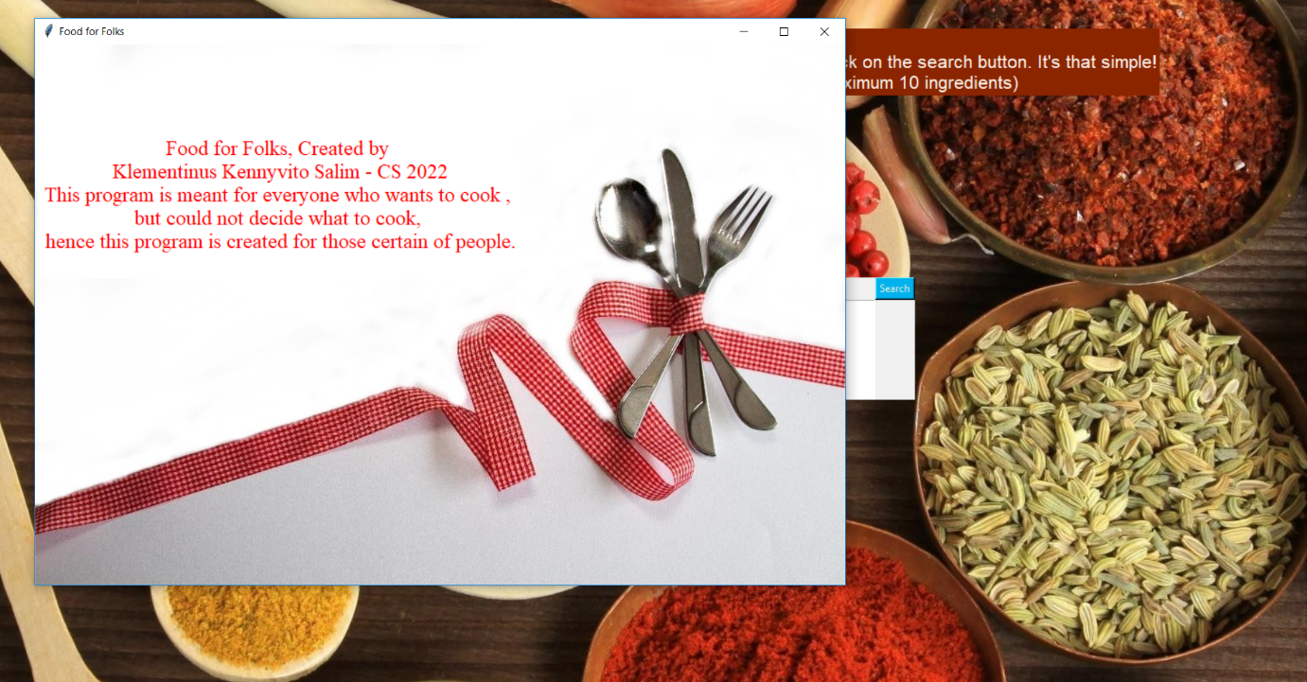

The about window

**Resources:**

<http://usingpython.com/making-widgets-look-nice/>

<https://images.pexels.com/photos/33718/cutlery-knife-fork-spoon.jpg?cs=srgb&dl=cutlery-decoration-fork-33718.jpg&fm=jpg>

<http://www.wallpapers-web.com/food-wallpapers/4454431.html>

<https://stackoverflow.com/questions/27639298/python-tkinter-open-a-new-window-with-a-button-prompt>

<https://stackoverflow.com/>

Investary Youtube:

<https://www.youtube.com/user/investary>

<https://www.youtube.com/watch?v=ic3__PoSq-4>

<https://www.youtube.com/watch?v=5e5mBDXojH4>

<https://www.youtube.com/watch?v=YCLTv6wh3jE>

<https://www.youtube.com/watch?v=HVQeV7xe310>

References :

Excelino

Asoka (Project report reference)